I plan on making a mobile website (maybe I’ll try application) that will provide resources for people about the Supplementary Nutrition Assistance Program (SNAP). For example, using a user’s location to provide a list/map of stores nearby where they can use their SNAP benefits, using their case number and state to let them know when their benefits are available, using their zip code to let them know what number to use to contact their local SNAP office, etc..

There are excel sheets available with data about store locations in each state, distribution of benefits based off of state and case number, eligibility. There’s also data online on the USDA website. I will probably make up user information to test the website. I found some data about demographics and spending, but I’m not sure if I’ll use it at the moment.

I’m not sure about assumptions, but I’m hoping that the data I have is complete (ex. not that much missing data). So while making my ER diagram, I learned that cities and counties are kind of different. I’ll fix that in the future. Also learned that I probably need more stuff on it.

For the website, I’m imagining that a user will have the option to login, create an account, or just continue without logging in (not sure if I’d want to actually let users create an account or if I just want to store their information locally since people don’t usually have multiple phones and then I don’t have to worry about storing their information – have to think about it a little bit). They’ll be able to browse through different information like “Stores nearby”, “Eligibility”, or “What can you buy”. For “Eligibility”, users will be able to complete a form and see whether they are eligible based on their state. If they’re eligible, they will be asked if they want to complete the application. If they want to apply, then they get redirected to an online application or to a page containing information about their local SNAP office if an online application is not available. “Stores nearby” is probably going to use Google maps with the user’s location and the various stores (will probably use longitude and latitude since you can calculate distance with that). If I have time, I might implement something so users can keep track of their spending (habits). It’ll require users to manually input their starting balance and what they’ve spent their benefits on (since I don’t think I can make it so that the numbers and information about their spending get automatically updated when they make a purchase). Users will be able to see how they’ve spent their benefits over time and also on what kind of products (dairy, bread, etc.). <- let me know what you think of this.

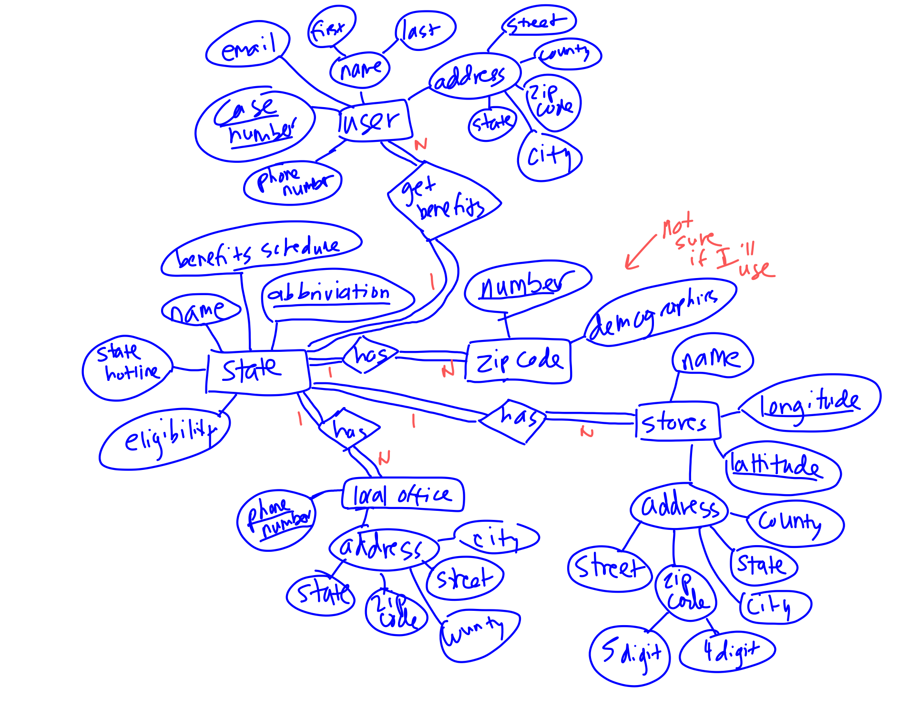

States(abbreviation, name, hotline, eligibility)

Benefits_schedule(state, uniform, first_date, last_date, day1, day2, day3, day4, day5, day6, day7, day8, day9, day10, day11, day12, day13, day14, day15)

Zip_codes_in_States(zip_code, state)

Zip_codes(number, demographics <- would be broken down into more attributes if I use)

Local_offices(phone_number, street, city, zip_code, state, county)

Stores(longitude, latitude, name, street, city, five_zip_code, four_zip_code, state, county)

User(case_number, first_name, last_name, street, city, zip_code, state, county)

Benefits_day(case_number, state, day)